16.14: a) 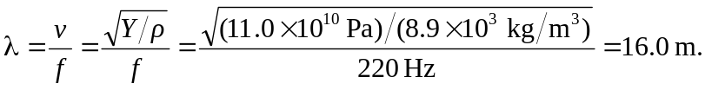
b) Solving for the amplitude A (as opposed to the area 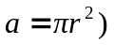in terms of the average power 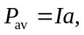
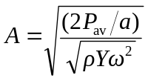
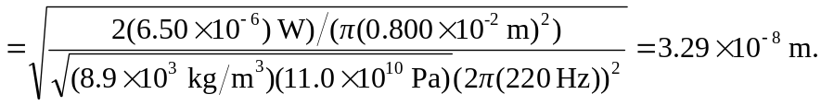

c)

